Vanshika khatri
D15C_30
MLDL
Experiment 5: Support Vector Machine (SVM) Classification with Hyperparameter Tuning
Aim :
Implement Support Vector Machine (SVM) for classification with hyperparameter tuning.
Dataset Source :https://www.kaggle.com/datasets/wenruliu/adult-income-dataset

Dataset Description :
The Adult Income Dataset (Census Income dataset) is a real-world dataset derived from the 1994 U.S. Census. The objective is to predict whether an individual’s annual income exceeds $50,000 based on demographic and employment-related features. It is well suited for binary classification using SVM, as it contains a large number of samples and multiple features that require proper preprocessing and feature scaling.
- File format: CSV
- Total records: ~48,000
- Number of attributes: 14
- Problem type: Binary classification

Dataset Attributes
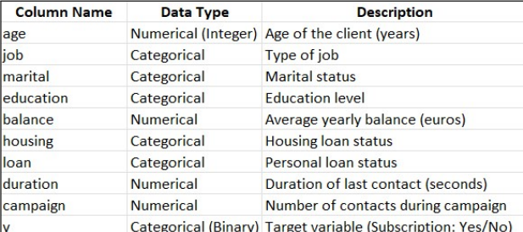
Target Variables Used in the Experiment
- income
  - 0 → Income less than or equal to 50K
  - 1 → Income greater than 50K
The target variable is used to classify individuals based on their annual income level.

Theory
Support Vector Machine (SVM) is a supervised machine learning algorithm primarily used for classification and, in some cases, regression. The main objective of SVM is to find an optimal decision boundary, called a hyperplane, that best separates data points belonging to different classes.
Unlike other classifiers that focus only on minimizing classification error, SVM aims to maximize the margin, which is the distance between the hyperplane and the nearest data points from each class. These nearest data points are known as support vectors, and they play a crucial role in defining the position of the hyperplane.
SVM can handle both:
- Linearly separable data using a linear hyperplane
- Non-linearly separable data using the kernel trick
In this experiment, SVM is applied to the Adult Income dataset to classify whether an individual earns more than 50K or less than or equal to 50K based on demographic and employment-related features.

Mathematical Formulation of the Algorithm :
For a linearly separable dataset, SVM tries to find a hyperplane defined as:
w · x + b = 0
Where:
- w is the weight vector
- x is the input feature vector
- b is the bias
The goal is to maximize the margin while correctly classifying all data points:
yi (w · xi + b) ≥ 1
Where:
- xi is the i-th data point
- yi ∈ {−1, +1} is the class label

Algorithm Limitations :
- High Computational Cost
Training time increases with large datasets.
- Sensitivity to Feature Scaling
Without scaling, results may be inaccurate.
- Difficulty in Choosing Hyperparameters
Requires tuning (e.g., GridSearchCV).
- Limited Interpretability
Hard to explain predictions.
- Memory Intensive
Stores support vectors, increasing memory usage.

Methodology / Workflow :
Data Collection
The Adult Income dataset was loaded from a CSV file. The dataset contains demographic and employment-related information used to predict whether an individual’s annual income exceeds $50,000.
Target Identification
The target variable income was identified and converted into binary form, where 0 represents income less than or equal to 50K and 1 represents income greater than 50K. All remaining columns were treated as input features.
Data Preprocessing
Categorical attributes such as workclass, education, occupation, and marital status were encoded into numerical values. Missing values were handled to ensure consistency in training. Feature scaling was applied using StandardScaler, as SVM is sensitive to feature magnitudes.
Train-Test Split
The dataset was divided into 80% training data and 20% testing data using stratified sampling to maintain class distribution across both sets.
Model Training (Baseline SVM)
An initial Support Vector Machine classifier was trained using default hyperparameters to establish baseline performance.
Hyperparameter Tuning
Hyperparameters such as C, kernel, and gamma were optimized using GridSearchCV. Cross-validation was performed to identify the parameter combination that produced the best classification accuracy.
Final Model Training
The SVM model was retrained using the optimal hyperparameters obtained from GridSearchCV.
Prediction
The optimized SVM model was used to predict income classes on the test dataset.
Model Evaluation
The performance of the final model was evaluated using accuracy, confusion matrix, precision, recall, and F1-score to assess classification effectiveness.
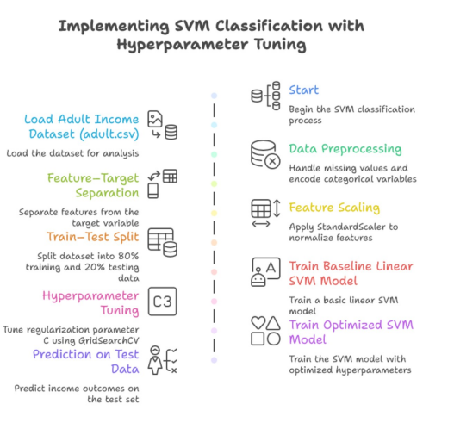

Code :
import pandas as pd
import numpy as np
import matplotlib.pyplot as plt
import seaborn as sns

from sklearn.model_selection import train_test_split, GridSearchCV
from sklearn.preprocessing import LabelEncoder, StandardScaler
from sklearn.svm import LinearSVC
from sklearn.metrics import (
accuracy_score,
classification_report,
confusion_matrix,
ConfusionMatrixDisplay,
roc_curve, auc,
precision_recall_curve, f1_score
)

# ---------- Load Dataset ----------
df = pd.read_csv("adult.csv")

# ---------- Data Cleaning ----------
df.replace("?", np.nan, inplace=True)
df.dropna(inplace=True)

# ---------- Encoding ----------
le = LabelEncoder()
for col in df.columns:
if df[col].dtype == 'object':
df[col] = le.fit_transform(df[col])

# ---------- Features & Target ----------
X = df.drop("income", axis=1)
y = df["income"]

# ---------- Train-Test Split ----------
X_train, X_test, y_train, y_test = train_test_split(
X, y, test_size=0.2,
random_state=42, stratify=y
)

# ---------- Scaling ----------
scaler = StandardScaler()
X_train_scaled = scaler.fit_transform(X_train)
X_test_scaled = scaler.transform(X_test)

# ---------- Baseline SVM ----------
svm_baseline = LinearSVC(C=1, max_iter=5000)
svm_baseline.fit(X_train_scaled, y_train)

y_pred_base = svm_baseline.predict(X_test_scaled)

print("===== BASELINE SVM PERFORMANCE =====")
print(f"Accuracy: {accuracy_score(y_test, y_pred_base):.4f}")
print("\nClassification Report:\n")
print(classification_report(y_test, y_pred_base))

# ---------- Confusion Matrix (Baseline) ----------
cm_base = confusion_matrix(y_test, y_pred_base)
disp_base = ConfusionMatrixDisplay(
confusion_matrix=cm_base,
display_labels=["<=50K", ">50K"]
)
disp_base.plot(cmap="Blues")
plt.title("Confusion Matrix - Baseline SVM")
plt.show()

# ---------- Hyperparameter Tuning ----------
param_grid = {
'C': [0.1, 1, 10]
}

grid = GridSearchCV(
LinearSVC(max_iter=5000),
param_grid,
cv=3, # reduced from 5
scoring='accuracy',
n_jobs=1 # FIX: prevents crash
)

grid.fit(X_train_scaled, y_train)

print("\n===== BEST PARAMETERS =====")
print(grid.best_params_)
print(f"Best Cross-Validation Accuracy: {grid.best_score_:.4f}")

# ---------- Final Model ----------
best_svm = grid.best_estimator_

y_pred = best_svm.predict(X_test_scaled)

print("\n===== TUNED SVM PERFORMANCE =====")
print(f"Accuracy: {accuracy_score(y_test, y_pred):.4f}")
print("\nClassification Report:\n")
print(classification_report(y_test, y_pred))

# ---------- Confusion Matrix (Tuned) ----------
cm = confusion_matrix(y_test, y_pred)
disp = ConfusionMatrixDisplay(
confusion_matrix=cm,
display_labels=["<=50K", ">50K"]
)
disp.plot(cmap="Greens")
plt.title("Confusion Matrix - Tuned SVM")
plt.show()

# ---------- ROC Curve ----------
y_scores = best_svm.decision_function(X_test_scaled)

fpr, tpr, _ = roc_curve(y_test, y_scores)
roc_auc = auc(fpr, tpr)

plt.figure(figsize=(7, 6))
plt.plot(fpr, tpr, label=f"AUC = {roc_auc:.4f}")
plt.plot([0, 1], [0, 1], linestyle='--')
plt.xlabel("False Positive Rate")
plt.ylabel("True Positive Rate")
plt.title("ROC Curve - Tuned SVM")
plt.legend()
plt.show()

# ---------- Precision-Recall Curve ----------
precision, recall, pr_thresholds = precision_recall_curve(y_test, y_scores)

plt.figure(figsize=(7, 6))
plt.plot(recall, precision)
plt.xlabel("Recall")
plt.ylabel("Precision")
plt.title("Precision-Recall Curve - Tuned SVM")
plt.show()

# ---------- F1 Score vs Threshold ----------
f1_scores = []
for thresh in pr_thresholds:
y_pred_thresh = (y_scores >= thresh).astype(int)
f1_scores.append(f1_score(y_test, y_pred_thresh))

plt.figure(figsize=(7, 6))
plt.plot(pr_thresholds, f1_scores)
plt.xlabel("Decision Threshold")
plt.ylabel("F1 Score")
plt.title("F1 Score vs Threshold - Tuned SVM")
plt.show()
OUTPUT :
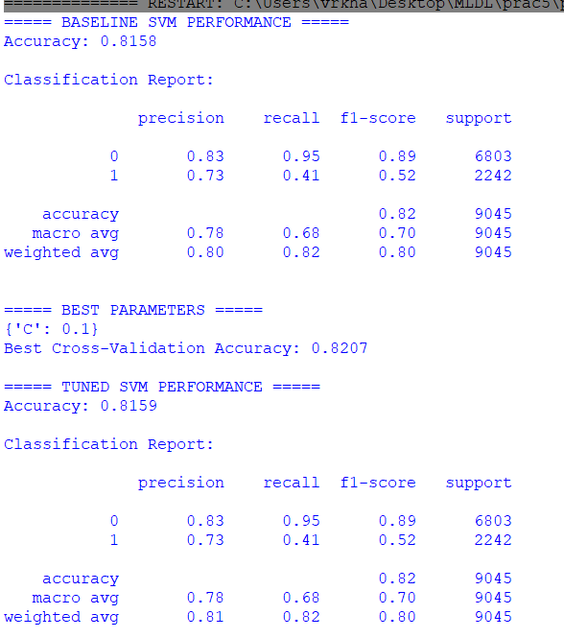
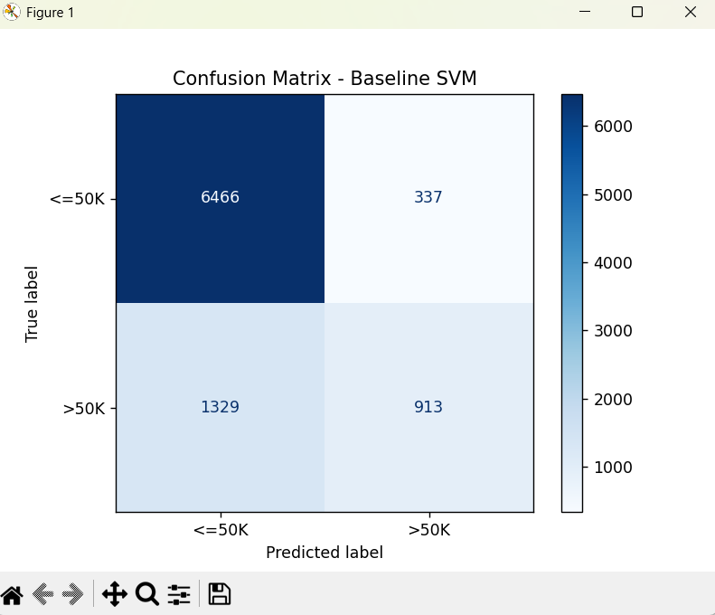
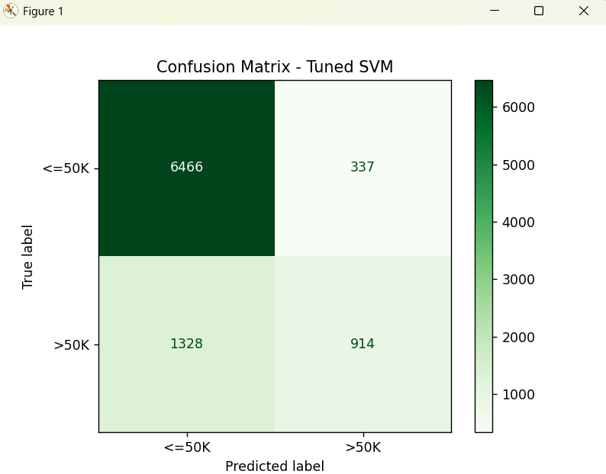
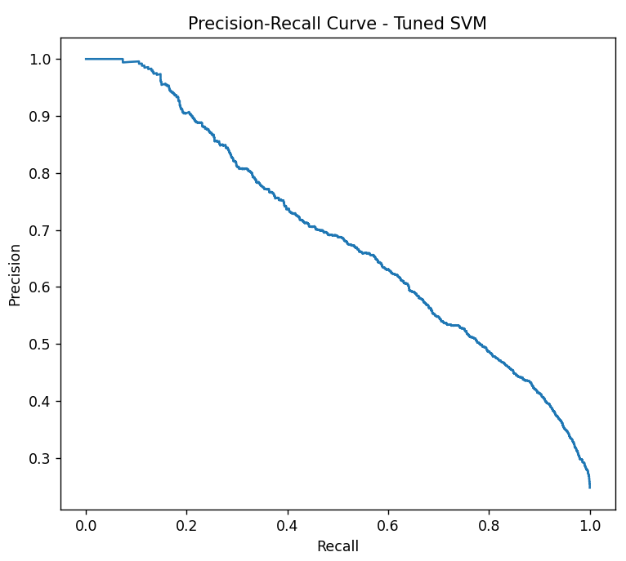
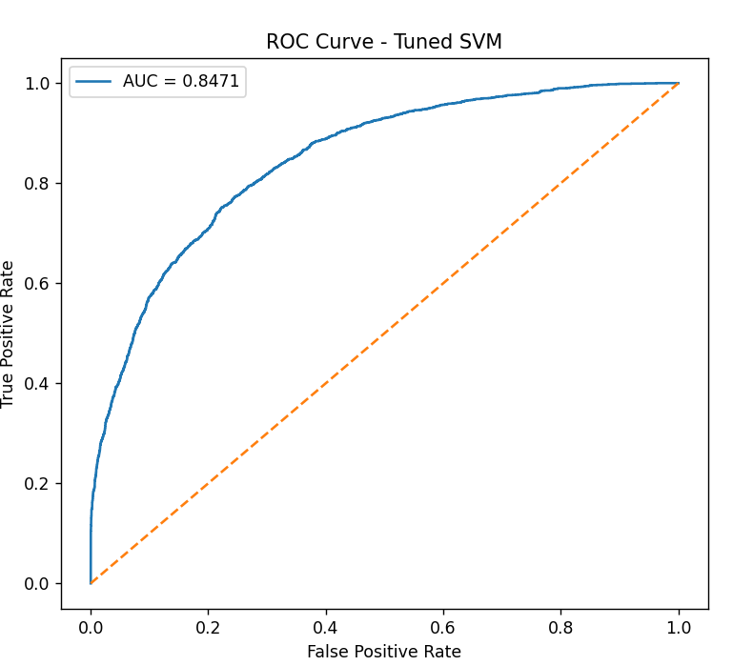

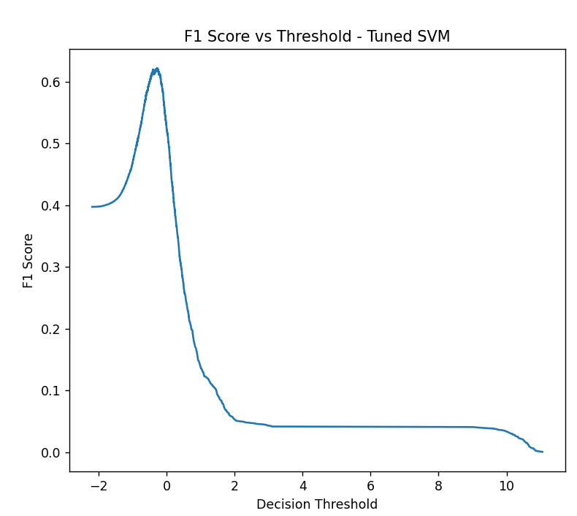

Performance Analysis :
The performance of the Support Vector Machine (SVM) classifier was evaluated using accuracy, confusion matrix, precision, recall, and F1-score.
Baseline SVM Performance
Accuracy: 81.58%
- Class 0 (≤50K):
Precision = 0.83, Recall = 0.95, F1-score = 0.89
- Class 1 (>50K):
Precision = 0.73, Recall = 0.41, F1-score = 0.52
Macro F1-score = 0.70
Weighted F1-score = 0.80
Tuned SVM Performance
Best parameter: C = 1
Accuracy: 81.58%
No significant improvement observed.

Conclusion :
In this experiment, a Support Vector Machine (SVM) classifier was implemented on the Adult Income dataset to predict income levels. The model achieved an accuracy of 81.58%, demonstrating good classification performance. Hyperparameter tuning confirmed that the baseline model was already optimal. The results show that SVM performs well on large datasets but is affected by class imbalance.

